1. Modal dialogues with options: JOptionPane.

The JOptionPane component is used to create small dialog boxes to inform, request confirmation, or even request some type of information entry. You have methods to perform each of those options. We are going to see the different options.

1.1. Show message to user.

This is the simplest way to display information to the user:

JOptionPane.showMessageDialog (null, "Operation Successful");

The result would be:

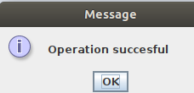

The showMessageDialog method has two parameters, with the first one it is indicated who the parent window is, it is not a necessary parameter and with the second one the string to show.

Another variant of this method can be:

JOptionPane.showMessageDialog (null, "Message inside window",
"Message in the title bar",
JOptionPane.WARNING_MESSAGE);

In this case the result is:

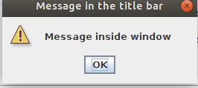

1.2. Ask for confirmation.

To request confirmation from the user, the showConfirmDialog method is used, this method returns the option chosen by the user:

//showConfirmDialog
confirmed int = JOptionPane.showConfirmDialog (null, "Do you confirm this?");

if (JOptionPane.OK_OPTION == confirmed)
System.out.println ("confirmed");
else
System.out.println ("ok ... I don't delete anything ...");

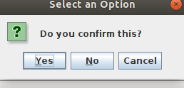

We can customize the content of the buttons and the response with showOptionDialog:

// showOptionDialog
int select = JOptionPane.showOptionDialog (
null, // parent component
"Select option",
"Options Selector",
JOptionPane.YES_NO_CANCEL_OPTION,
JOptionPane.QUESTION_MESSAGE,
null, // null for default icon or an icon.
new Object [] {"option 1", "option 2", "option 3"},
// null for YES, NO and CANCEL
"option 1");
if (select! = -1)
System.out.println ("selected option" + (selection + 1));

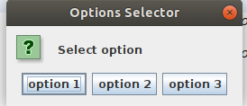

1.3. Request some data from the user.

To request some type of data from the user, we use the showInputDialog method:

// With text box
String sel = JOptionPane.showInputDialog (
null,
"Input dialog",
JOptionPane.QUESTION_MESSAGE); // the icon will be a questioner

System.out.println ("The user has typed" + sel);

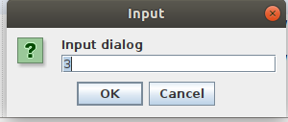

It is also possible to give the user the possibility to choose the data of a combo:

// With JCombobox
Object selec = JOptionPane.showInputDialog (
null,
"Select option",
"Options Selector",
JOptionPane.QUESTION_MESSAGE,
null, // null for default icon
new Object [] {"option 1", "option 2", "option 3"},
"option 1");

System.out.println ("The user has chosen" + selec);

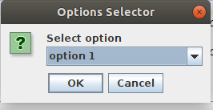

2.Menus.

To create a menu we have three swing classes: JMenuBar, JMenu and JMenuItem. With the first we create the menu bar, to this menu bar we will add the various options with JMenu and to each JMenu we will add its items with JMenuItem. It is best to build a menu to understand how it works:

// MENU ITEMS:
JMenuBar menuBar;
JMenu menu;
JMenuItem menuItem;
// We instantiate the menu bar.
menuBar = new JMenuBar ();
// The first option on the menu.
menu = new JMenu ("First Menu");
menuBar.add (menu);
// to the first option of the menu we put two items.
menuItem = new JMenuItem ("Option 1");
menu.add (menuItem);
menu.addSeparator (); //separator
menuItem = new JMenuItem ("Option 2");
menu.add (menuItem);
// Second option in the menu bar without any item.
menu = new JMenu ("Second Menu");
menuBar.add (menu);

This would be:

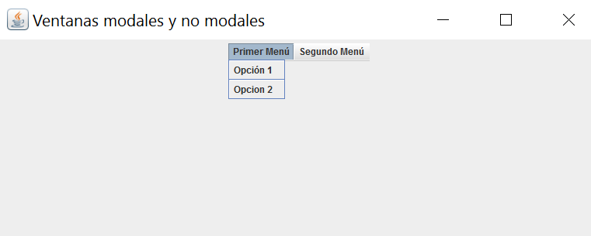

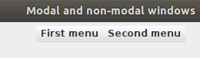

3. Custom dialogues: JDialog.

In java we can create windows that will be called from a JFrame, for this we can use the JDialog classes. In a JDialog we can include the same elements as a JFrame, but the main difference is that a JDialog must be told, when it is instantiated, who its father is. The idea is to have a main window in our application, a JFrame, which will become the parent of the other necessary windows that will be JDialog.

We are going to create a JDialog, to be called from a JFrame:

public class DialogoModal extends JDialog {
private JTextField textField;

public DialogoModal (JFrame parent) {
// the constructor receives as parameter that window
// who called him, that is, his father

super (parent, true); // I invoke the constructor of the case, with two
// parameters: who is your father
// then true for modal and false for non-modal

setTitle ("Enter a data");
textField = new JTextField (20);
add (textField);

// The window is hidden when pressing <enter> on the textfield
textField.addActionListener (new ActionListener () {
public void actionPerformed (ActionEvent arg0) {
setVisible (false);
}
});
}

public String getText () {
return textField.getText ();
}
}

We are going to call this window from the JFrame that contains the menu created in point 2:

public class menu extends JFrame {
public menu () {
setSize (800,600);
setTitle ("Modal and non-modal windows");
setDefaultCloseOperation (EXIT_ON_CLOSE);
setLayout (new FlowLayout ());
//MENU:
JMenuBar menuBar;
JMenu menu;
JMenuItem menuItem;
// Create the menu bar.
menuBar = new JMenuBar ();
// Build the first menu.
menu = new JMenu ("First Menu");
menuBar.add (menu);
// a group of JMenuItems
menuItem = new JMenuItem ("Option 1");
// Add listener to a menu option:
menuItem.addActionListener (new em (this));
menu.add (menuItem);
menu.addSeparator ();
menuItem = new JMenuItem ("Option 2");
menu.add (menuItem);
// Build second menu in the menu bar.
menu = new JMenu ("Second Menu");
menuBar.add (menu);
add (menuBar);

}
// LISTEN OUT:
class em implements ActionListener {
JFrame miFrame;
public em (JFrame f) {
myFrame = f;
}
public void actionPerformed (ActionEvent e) {
DialogoModal dialogoModal = new DialogoModal (myFrame);
dialogModal.pack ();
// to automatically resize the window.
dialogoModal.setVisible (true);
// As it is a modal window it will not return to this line
// until the other one is closed
System.out.println (dialogoModal.getText ());
}
}

}

The code in red serves to highlight what the JDialog is called and how it is passed to who is the parent window.

4. NetBeans projects.

You can find two projects with this UD. The first contains the calls to JOptionPane from point 1 and the second has the menus from point 2 and the JDialog from point 3.

